# Algorithm Projected Performance

### Results Plot

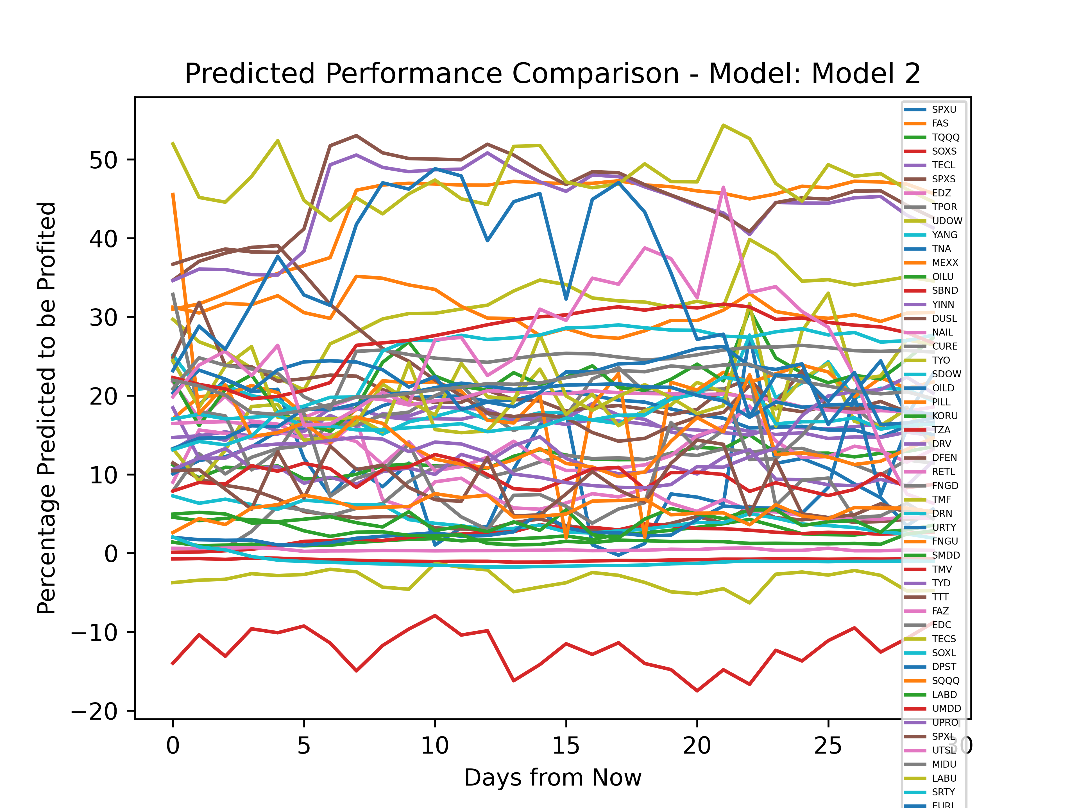

The Best Overall Performing ETF Was: LABU, with an average growth of: 47.386196

ETF: SPXU profited 10.616439%. The Neural Network generated a Training Loss of ~473, and a Validation Loss of ~459

ETF: FAS profited 43.674496%. The Neural Network generated a Training Loss of ~1352, and a Validation Loss of ~1274

ETF: TQQQ profited 11.835512%. The Neural Network generated a Training Loss of ~1347, and a Validation Loss of ~1281

ETF: SOXS profited -12.170009%. The Neural Network generated a Training Loss of ~186, and a Validation Loss of ~235

ETF: TECL profited 16.259352%. The Neural Network generated a Training Loss of ~1142, and a Validation Loss of ~852

ETF: SPXS profited 4.8827844%. The Neural Network generated a Training Loss of ~523, and a Validation Loss of ~502

ETF: EDZ profited 8.324291%. The Neural Network generated a Training Loss of ~513, and a Validation Loss of ~491

ETF: TPOR profited 9.321243%. The Neural Network generated a Training Loss of ~359, and a Validation Loss of ~323

ETF: UDOW profited 31.143322%. The Neural Network generated a Training Loss of ~2355, and a Validation Loss of ~2267

ETF: YANG profited 19.296959%. The Neural Network generated a Training Loss of ~496, and a Validation Loss of ~457

ETF: TNA profited 16.93521%. The Neural Network generated a Training Loss of ~1105, and a Validation Loss of ~1173

ETF: MEXX profited 30.661844%. The Neural Network generated a Training Loss of ~696, and a Validation Loss of ~653

ETF: OILU profited 2.1197782%. The Neural Network generated a Training Loss of ~4875, and a Validation Loss of ~4458

ETF: SBND profited 2.257579%. The Neural Network generated a Training Loss of ~121, and a Validation Loss of ~118

ETF: YINN profited 16.163425%. The Neural Network generated a Training Loss of ~1230, and a Validation Loss of ~1305

ETF: DUSL profited 20.399206%. The Neural Network generated a Training Loss of ~514, and a Validation Loss of ~475

ETF: NAIL profited 13.868726%. The Neural Network generated a Training Loss of ~1053, and a Validation Loss of ~990

ETF: CURE profited 16.61289%. The Neural Network generated a Training Loss of ~1142, and a Validation Loss of ~1070

ETF: TYO profited 18.203474%. The Neural Network generated a Training Loss of ~657, and a Validation Loss of ~645

ETF: SDOW profited 4.2699146%. The Neural Network generated a Training Loss of ~373, and a Validation Loss of ~428

ETF: OILD profited 4.591044%. The Neural Network generated a Training Loss of ~9, and a Validation Loss of ~6

ETF: PILL profited 19.207731%. The Neural Network generated a Training Loss of ~532, and a Validation Loss of ~536

ETF: KORU profited 22.073341%. The Neural Network generated a Training Loss of ~723, and a Validation Loss of ~605

ETF: TZA profited -0.86316025%. The Neural Network generated a Training Loss of ~424, and a Validation Loss of ~343

ETF: DRV profited 11.049719%. The Neural Network generated a Training Loss of ~451, and a Validation Loss of ~529

ETF: DFEN profited 23.164042%. The Neural Network generated a Training Loss of ~615, and a Validation Loss of ~635

ETF: RETL profited 18.897993%. The Neural Network generated a Training Loss of ~1373, and a Validation Loss of ~1314

ETF: FNGD profited 10.491881%. The Neural Network generated a Training Loss of ~576, and a Validation Loss of ~556

ETF: TMF profited 21.237585%. The Neural Network generated a Training Loss of ~738, and a Validation Loss of ~602

ETF: DRN profited 17.136381%. The Neural Network generated a Training Loss of ~814, and a Validation Loss of ~755

ETF: URTY profited 18.961378%. The Neural Network generated a Training Loss of ~990, and a Validation Loss of ~789

ETF: FNGU profited 15.062787%. The Neural Network generated a Training Loss of ~1036, and a Validation Loss of ~765

ETF: SMDD profited 4.120871%. The Neural Network generated a Training Loss of ~1073, and a Validation Loss of ~1162

ETF: TMV profited 9.546322%. The Neural Network generated a Training Loss of ~489, and a Validation Loss of ~487

ETF: TYD profited 13.482878%. The Neural Network generated a Training Loss of ~1118, and a Validation Loss of ~964

ETF: TTT profited 8.433936%. The Neural Network generated a Training Loss of ~492, and a Validation Loss of ~545

ETF: FAZ profited 0.41587394%. The Neural Network generated a Training Loss of ~1299, and a Validation Loss of ~1081

ETF: EDC profited 24.562399%. The Neural Network generated a Training Loss of ~935, and a Validation Loss of ~851

ETF: TECS profited -3.4216647%. The Neural Network generated a Training Loss of ~234, and a Validation Loss of ~184

ETF: SOXL profited 24.723955%. The Neural Network generated a Training Loss of ~1167, and a Validation Loss of ~1155

ETF: DPST profited 22.319876%. The Neural Network generated a Training Loss of ~1154, and a Validation Loss of ~1285

ETF: SQQQ profited 5.5575967%. The Neural Network generated a Training Loss of ~164, and a Validation Loss of ~153

ETF: LABD profited 2.2088265%. The Neural Network generated a Training Loss of ~554, and a Validation Loss of ~506

ETF: UMDD profited 27.354794%. The Neural Network generated a Training Loss of ~909, and a Validation Loss of ~920

ETF: UPRO profited 44.216427%. The Neural Network generated a Training Loss of ~1506, and a Validation Loss of ~1294

ETF: SPXL profited 45.472885%. The Neural Network generated a Training Loss of ~1471, and a Validation Loss of ~1464

ETF: UTSL profited 25.699747%. The Neural Network generated a Training Loss of ~1924, and a Validation Loss of ~1609

ETF: MIDU profited 21.163311%. The Neural Network generated a Training Loss of ~1396, and a Validation Loss of ~1435

ETF: LABU profited 47.386196%. The Neural Network generated a Training Loss of ~1711, and a Validation Loss of ~1622

ETF: SRTY profited -1.0437325%. The Neural Network generated a Training Loss of ~383, and a Validation Loss of ~422

ETF: EURL profited 32.85284%. The Neural Network generated a Training Loss of ~1942, and a Validation Loss of ~1913